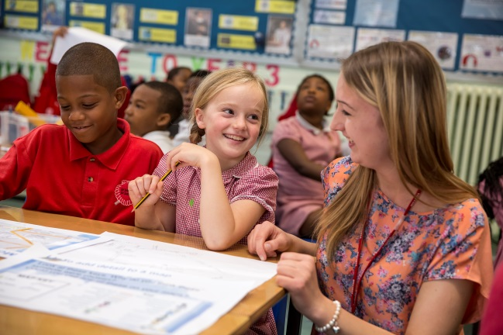gh

Welcome to our first newsletter!

Thank you for taking the time to read our first newsletter to the local communities of the schools in the Primary Advantage Federation. Staff, children and governors will be sharing news of activities and events that have taken place over the school year.  
  
We hope the newsletter will provide more information of how our schools work together for our children.  
  
Sian Davies Gwen Gutzmore  
Executive Principal Chair of Governors

Primary Advantage Federation

Newsletter

**Primary Advantage Federation’s First Newsletter!**

[www.primaryadvantage.co.uk](http://www.primaryadvantage.co.uk)

**Newsletter 1**

**Spring 2016**

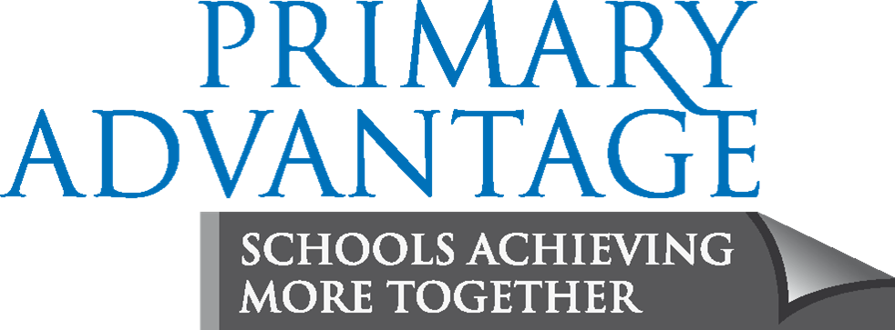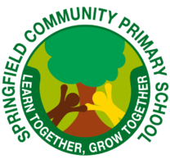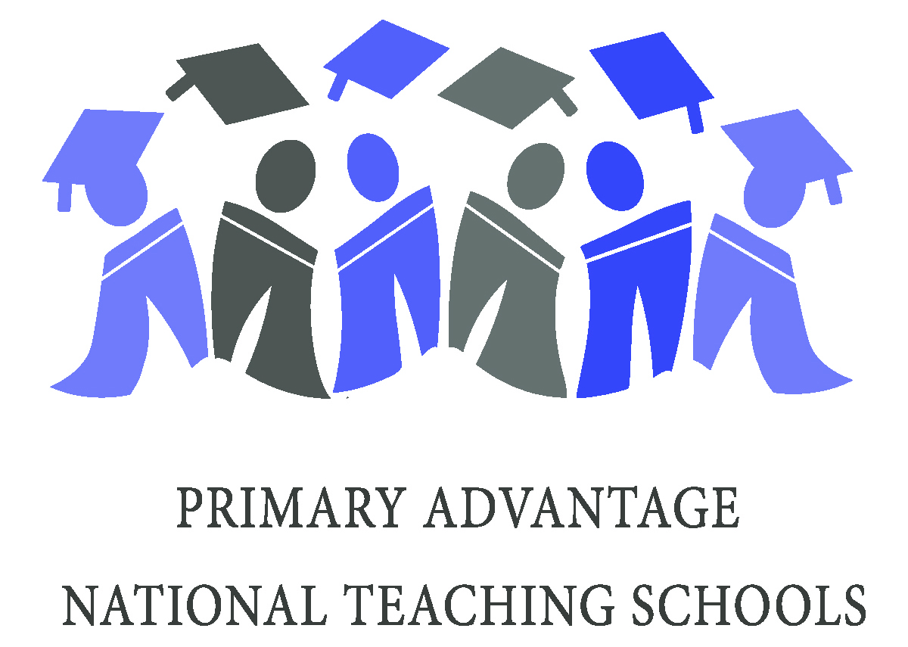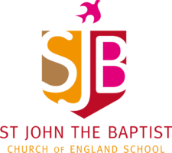

We are a group of schools working together because we believe our schools can gain more by working together. We have a commitment to a shared responsibility to the wider school community, the provision of good quality education and the improvement of life chances for the pupils in the community beyond that of own schools. Being part of a federation is not an academy or an academy chain – just simply schools coming together to provide more for our children.

Our full governing body meets every term. As well as discussing school budgets, policies and procedures, our governors review the progress they have made over the year and set targets to further develop the work we do. In September, our governing body set three targets:

1. To implement an assessment programme across the federation of schools

2. Improve the effectiveness of the governing body

3. Improve the attainment and progress for more able pupils

At the next meeting in April and over the summer term, our members will review their performance against the targets set and will issue a governor statement via the [Primary Advantage Website](http://www.primaryadvantage.co.uk).

We have 20 governors on the federated governing body. Each governor is part of a school committee which meets at least four times a year and supports the Headteacher and Executive Principal in making strategic decisions that will improve outcomes for pupils.

Each school committee reports to the full governing body once a term. Our school committee includes representatives from our parents, staff and community.

On our website you can find information about the federation, and governor member attendance. More information about school committee members can be found on our school websites.

Work completed by the Federated Governing Body



We are a group of schools working together because we believe our schools can gain more by working together. We have a commitment to a shared responsibility to the wider school community, the provision of good quality education and the improvement of life chances for the pupils in the community beyond that of own schools.

Being part of the federation – what does it mean?

**Shoreditch Town Hall**

This month Year 4A had the pleasure of

being able to listen to a love orchestra in

Shoreditch Town Hall during our Apollo Music workshop. The class got to listen to some of the classical music they have been learning about over the course of the year. After the performance they were able to speak to the orchestra players individually about their respective instruments as these have been a focus in their learning.



**Hackney Debate Challenge**

Holy Trinity’s debaters had the fantastic opportunity to compete against other schools in Hackney.

On Monday 29th February our team took part in the Hackney Debate Challenge, which was held at Linklater's law firm, in the City of London!

Our fabulous Year 4 team flexed their debating muscles to win both heats, beating children in Year 5.

**We love History at Springfield**

Springfield travelled back in time on the 23rd March and looked and felt like a very different school! To celebrate all the great work that had been happening in History, all the children and staff took the opportunity to dress up in costumes from the past. Our school was full of Roman gladiators, Victorian chimney sweeps, Egyptian goddesses and World War 2 soldiers. Classrooms were transformed into museums full of artefacts from the past and the week finished with an exciting theatre performance. looking at Roman Britiain.experience , based on Roman Britain.

Did you know that some of our schools are Teaching Schools? Teaching Schools are outstanding schools that work with others to provide high-quality training and development to new and experienced school staff. This year we have been lucky to have 30 student teachers join our schools and partnership schools. These students will rotate on practice and complete their training in July 2016.

In September, all teaching staff attended a staff training day to see the launch of the Primary Advantage approach to ‘Fundamentals’. Fundamentals is an approach to assessment which was launched across the federation on the first day of term and was followed up by a range of workshops. Whole federation staff training days have proven to be very successful and continue throughout the school year.

**Teaching Schools**

**Kensington Palace**

Pupils in Year 2 are learning about People of the Past. In February, they were lucky enough to have the opportunity to visit Kensington Palace to help them to find out more about Queen Victoria.

*“We found out about Queen Victoria’s family tree and we got to see her bedroom and her wedding dress; it was beautiful.” - Mia B*

**Lawrence Vigouroux, Liverpool**

**Goalkeeper visits!**

In February, Lawrence Vigouroux visited St John the Baptist. Lawrence is a goalkeeper, playing for Liverpool and currently on loan to Swindon. He presented an assembly to the children and they were all interested to hear how he had preserved with his sport and achieved success in his career, After the assembly, Lawrence visited the classrooms and spent time with the children.

**Brilliant Club**

We would like to say many congratulations to our "Brilliant Club" members. After weeks of tutorials and two university visits they completed a 1000 word essay on Fairness. In October the children were invited to the Kings College London for their Graduation. All of our students graduated with honours. A huge well done to Kunbi and Malaika P who graduated with distinctions and had their work published in an academic journal.

News from our schools and federation activities